Social studies is the integrated study of economics, geography, history, political science, and the behavioral sciences of psychology, sociology, and anthropology to promote civic competence. This area of study provides an important foundation to prepare students to become engaged, informed participants committed to the ideas and values of our democratic republic, able to apply the skills of inquiry, collaboration, decision making, and problem solving (adapted from the National Council for the Social Studies deﬁnition). Students will become civically-engaged problem-solvers who critically examine their roles in local, regional, state, national, and global communities. Through the study and application of the individual disciplines of social studies (behavioral sciences, economics, geography, history, and political science), students become lifelong learners able to collaborate and thrive in our interdependent world.
Description of Subject Area:
K-12
Grade Levels:
6th Grade - World Cultures and Geography
7th Grade- World History
8th Grade – US History
Courses:

Course Name: Grade 6 Social Studies | Department: Social Studies
Grade Level: 6 | Duration: All year
Resource: National Geographic Learning. (2017). World Cultures and Geography. CENGAGE.

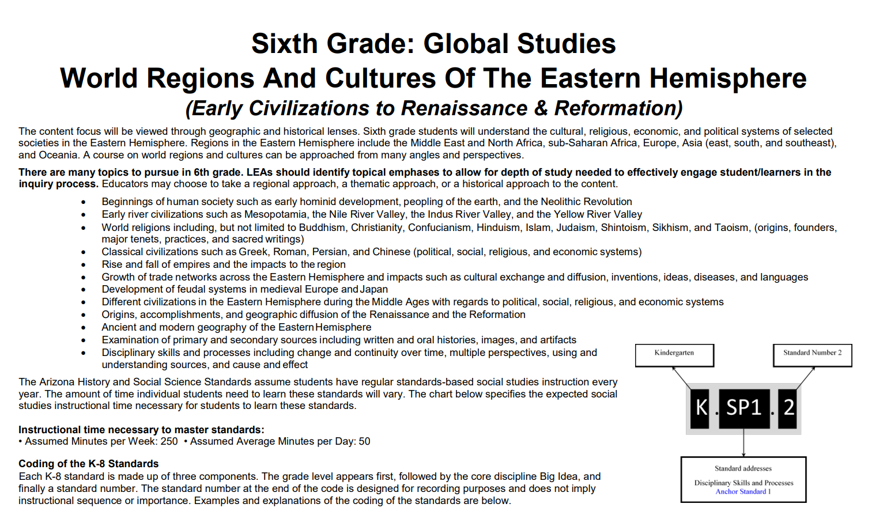
Course Overview: The major theme for social studies is world geography. Content of the course addresses physical geography and cultural, economic, social and political developments in the major regions of the world: Europe, Asia, Africa, and Eurasia. Students also integrate knowledge of speciﬁc historical eras into their study of regions of the world. Students are expected to monitor current event magazine, speciﬁc Internet sites, newspapers and other media to develop an understanding of current issues affecting these areas. Map skills and geographic literacy are incorporated throughout the year. Research skills utilizing technology and nonﬁction text is also an integral part of the curriculum.

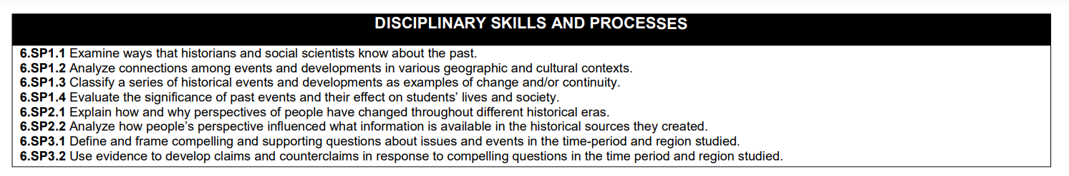
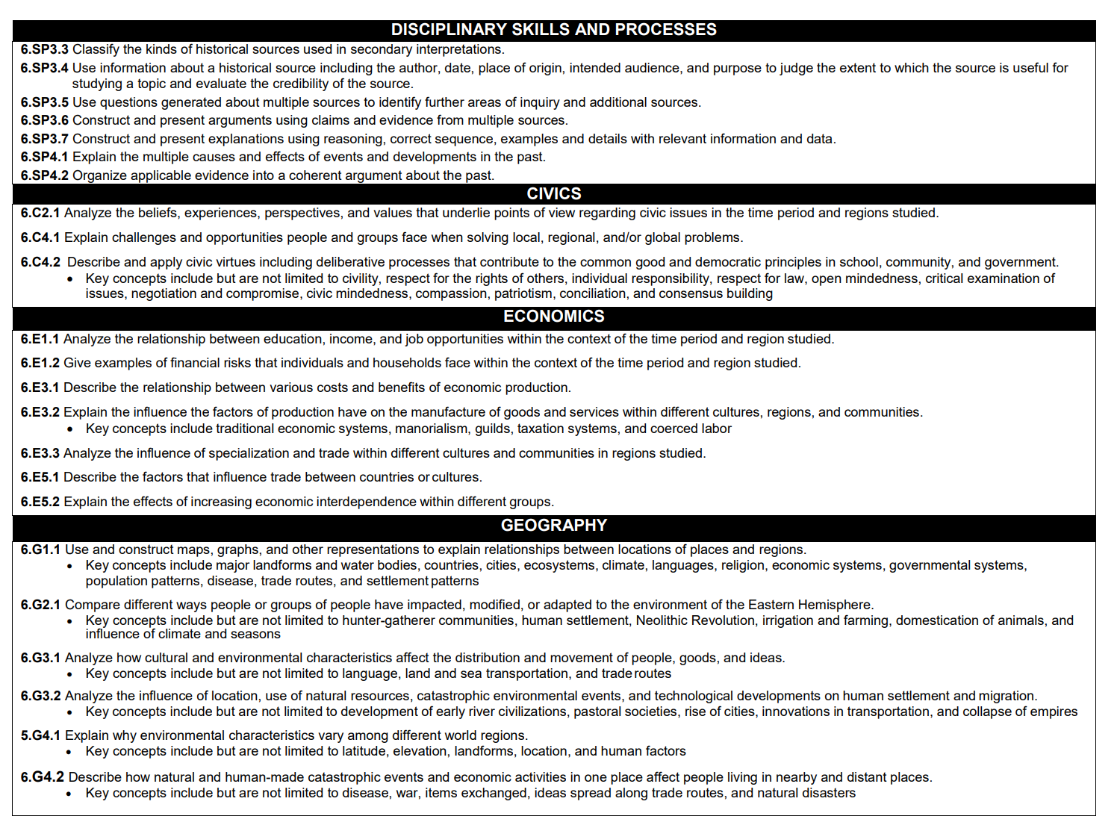
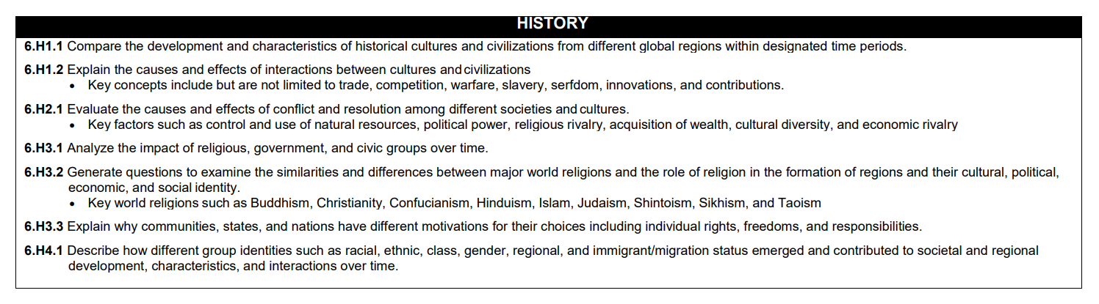

Content Focus: The content focus will be viewed through geographic and historical lenses. Sixth grade students will understand the cultural, religious, economic, and political systems of selected societies in the Eastern Hemisphere. Regions in the Eastern Hemisphere include the Middle East and North Africa, sub-Saharan Africa, Europe, Asia (east, south, and southeast), and Oceania. A course on world regions and cultures can be approached from many angles and perspectives.

Topics: There are many topics to pursue in 6th grade. LEAs should identify topical emphases to allow for depth of study needed to effectively engage student/learners in the inquiry process.
Educators may choose to take a regional approach, a thematic approach, or a historical approach to the content.
- Beginnings of human society such as early hominid development, peopling of the earth, and the Neolithic revolution
- Early river civilizations such as Mesopotamia, the Nile River Valley, the Indus River Valley, and the Yellow River Valley
- World religions including, but not limited to Buddhism, Christianity, Confucianism, Hinduism, Islam, Judaism, Shintoism, Sikhism, and Taoism, (origins, founders, major tenets, practices, and sacred writings)
- Classical civilizations such as Greek, Roman, Persian, and Chinese (political, social, religious, and economic systems)
- Rise and fall of empires and the impacts to the region
- Growth of trade networks across the Eastern Hemisphere and impacts such as cultural exchange and diffusion, inventions, ideas, diseases, and language
- Development of feudal systems in medieval Europe and Japan
- Different civilizations in the Eastern Hemisphere during the Middle Ages with regards to political, social, religious, and economic systems
- Origins, accomplishments, and geographic diffusion of the Renaissance and the Reformation
- Ancient and modern geography of the Eastern Hemisphere
- Examination of primary and secondary sources including written and oral histories, images, and artifacts
- Disciplinary skills and processes including change and continuity over time, multiple perspectives, using and understanding sources, and cause and effect

Curriculum Pacing:

Topics/Units: | Time Frame:
1. The Essentials of Geography: The disparity among developed, developing and newly industrialized nations is widening. Students will grapple with the disparities that exist in our world and begin to understand the theories as to why this is occurring. Students will analyze disparity through economic indicators such as GDP, literacy, life expectancy, etc (Human Development Index). Current data will be accessed through credible online sources. | 5 weeks
2. South Asia: The region of South Asia encompasses towering mountains, low fertile river plains, dense varied populations, diverse religions, and globalized economies. Students will explore this highly changing and inﬂuential region of the world. Furthermore, students will begin to better understand the historical implications of isolationism, colonialism, and trade practices as each plays a role in current issues. | 3 weeks
3. East Asia and Southeast Asia: The region of East Asia and Southeast Asia encompasses towering mountains, low fertile river plains, dense varied populations, diverse religions, and globalized economies. Students will explore this highly changing and inﬂuential region of the world. Furthermore, students will begin to better understand the historical implications of isolationism, colonialism, and trade practices as each plays a role in current issues. | 5 weeks
4. North Africa and Southwest Asia: This unit focuses on a study of the changes that occur in the use and importance of natural resources. Students will also study the physical environment and the complex relationship people have with their environment. Students will analyze the historic and current issues related to cooperation and conﬂict among people in this region of the world. | 5 weeks
5. Africa South of the Sahara: Africa South of the Sahara is a land of challenges - ethnic divisions, an AIDS epidemic, developing nations that struggle to establish order and economic growth, and traditional values and practices that run up against a modern world. Yet, Africa is also rich in beautiful landscapes, diverse resources, and interesting cultures full of music, art, and  story-telling. Additionally, an African history timeline that travels from the great nations of the Bantu or Zulu to the consequences/inﬂuences of colonization will be studied. Students will further analyze how these historical topics impact Africa's struggle with current issues, and in  the end, help to explain why TIA- "This is Africa". | 5 weeks

6. Australia, the Pacific Realms, and Antarctica: Throughout the unit, students will study Oceania which is made up of thousands of islands throughout the Central and South Pacific Ocean. It includes Australia, the smallest continent in terms of total land area. Most of Oceania is under the Pacific, a vast body of water that is larger than all the Earth’s continental landmasses and islands combined. The name “Oceania” justly establishes the Pacific Ocean as the defining characteristic of the continent. | 5 weeks
7. Middle and South America: A regional study of Middle and South America includes a study of the signiﬁcance of land features and climate regions and the role they play in how people adapt to their environment. A study of Latin American cultures including the Maya, Inca, and Aztec civilizations provides an historical perspective. Students will also consider the economic relationship between the United States and Middle and South America and the economic structure of ingrained economic systems in the Americas. Contemporary issues will be explored such as the cutting down of the rainforest or population and pollution impact in major cities in this region. | 5 weeks
8. International History Timeline: Major historical events, inventions, discoveries, etc. will be compiled on a multi-regional timeline to foster an international perspective of world history. Students will review the regions studied during the year to analyze historical events, inventions, discoveries, etc. and select the most signiﬁcant ones to include in the timeline. To do this, students will establish criteria and will be able to justify why their selections were included. | 2 weeks

Course Name: Grade 7 Social Studies | Department: Social Studies
Grade Level: 7 | Duration: All year
Resource: National Geographic Learning. (2016). World History: Great Civilizations. CENGAGE.
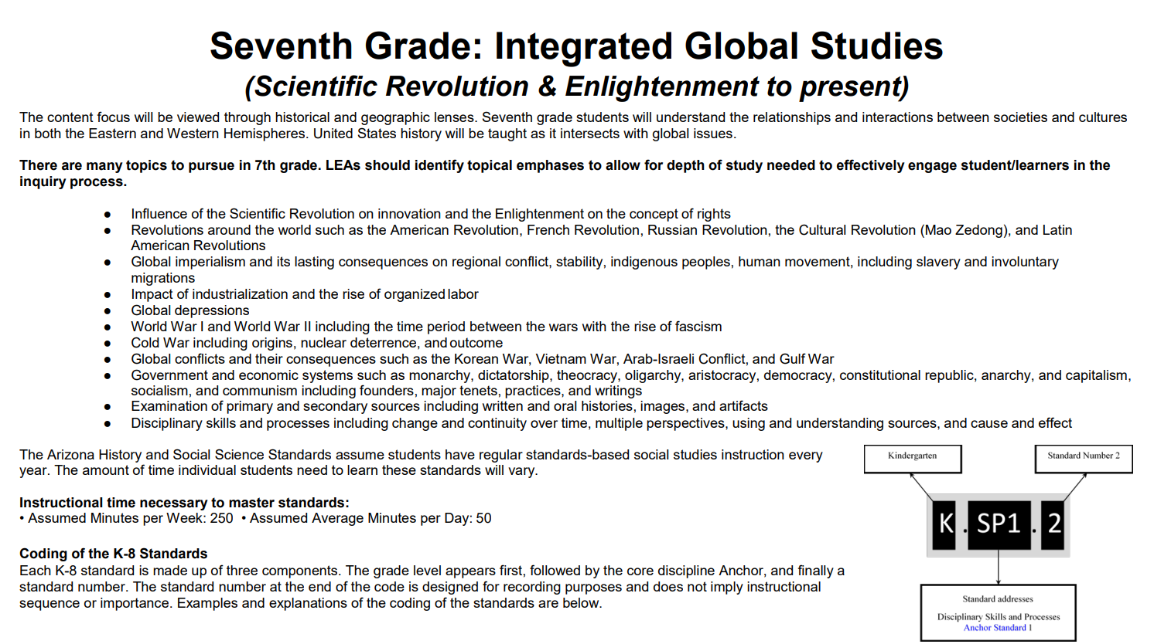
Course Overview: Seventh grade social studies introduces world history, culture, and geography. Students explore the methods and techniques geographers, archaeologists, historians, and other scholars use to analyze and learn about the past. The various units of study provide a chronological overview of the major ancient civilizations in world history from early hunter-gatherer societies to the Renaissance. Current events are also a component of the seventh-grade social studies curriculum.

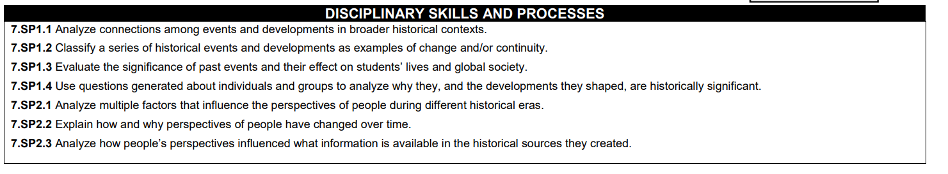

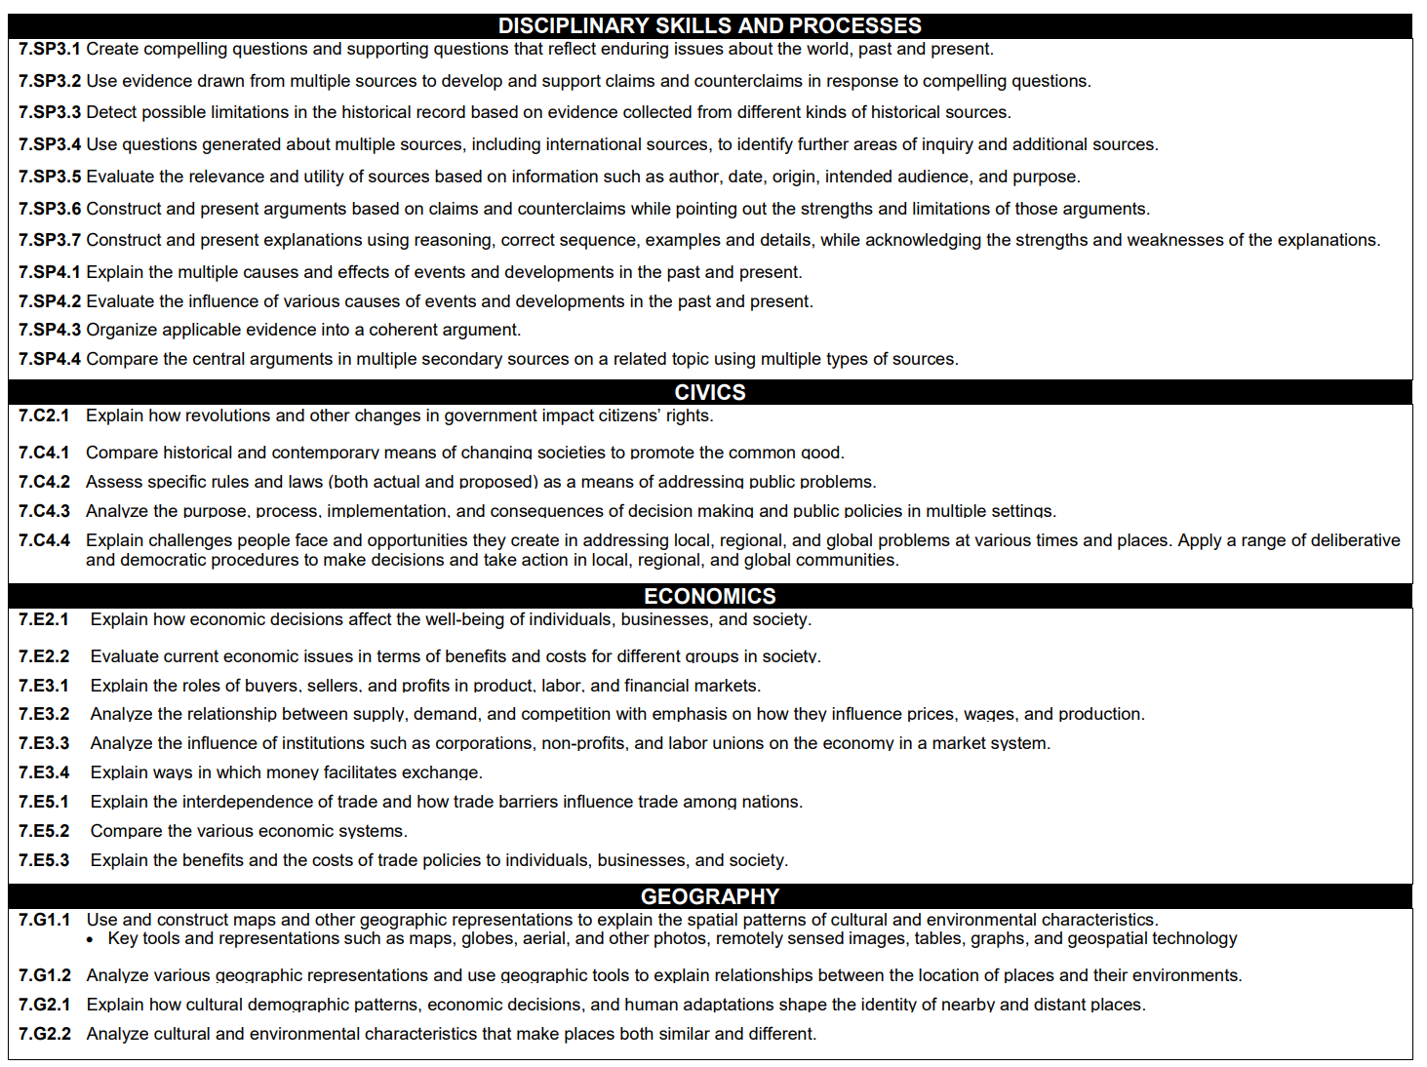
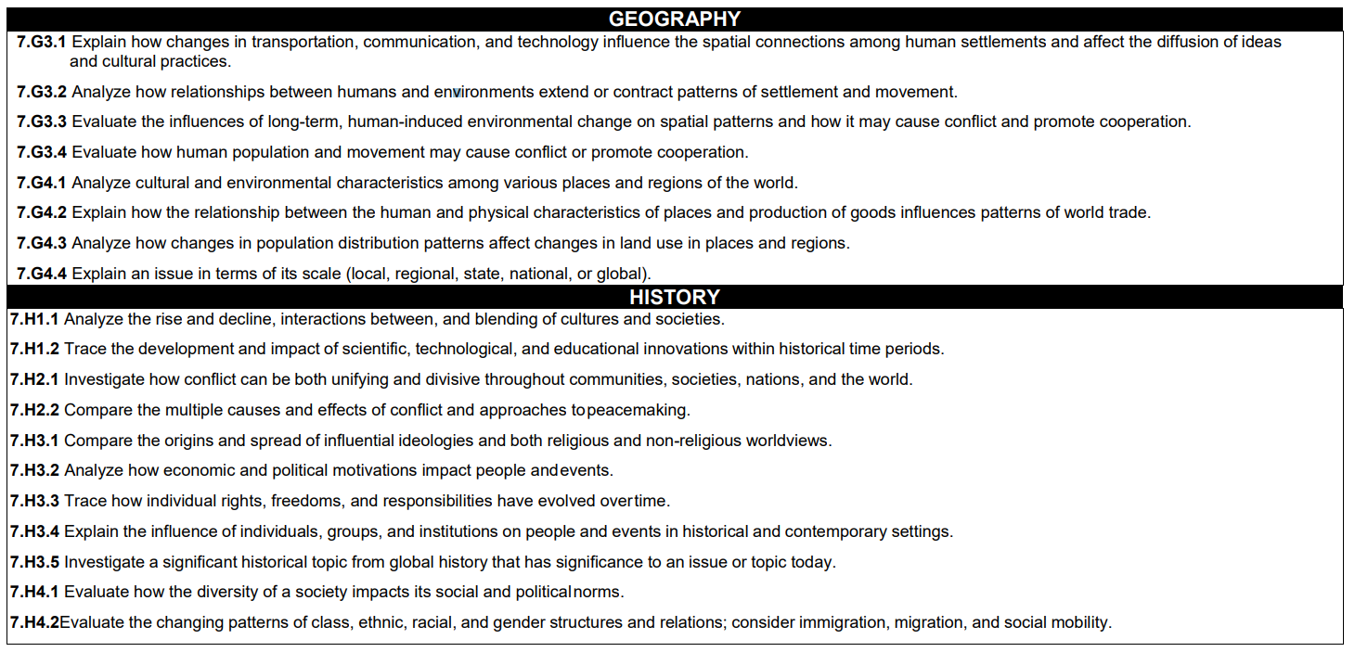

Content Focus: Scientific Revolution & Enlightenment -present

The content focus will be viewed through historical and geographic lenses. Seventh grade students will understand the relationships and interactions between societies and cultures in both the Eastern and Western Hemispheres. United States history will be taught as it intersects with global issues.

Topics: There are many topics to pursue in 7th grade. LEAs should identify topical emphases to allow for depth of study needed to effectively engage student/learners in the inquiry process.

- Influence of the Scientific Revolution on innovation and the Enlightenment on the concept of rights
- Revolutions around the world such as the American Revolution, French Revolution, Russian Revolution, the Cultural Revolution (Mao Zedong), and Latin American revolutions
- Global imperialism and its lasting consequences on regional conflict, stability, indigenous peoples, and human movement, including slavery and involuntary migrations
- Impact of industrialization and the rise of organized labor
- Global depressions
- World War I and World War II including the time period between the wars with the rise of fascism
- Cold War including origins, nuclear deterrence, and outcome
- Global conflicts and their consequences such as the Korean War, Vietnam War, Arab-Israeli Conflict, and Gulf War
- Government and economic systems such as monarchy, dictatorship, theocracy, oligarchy, aristocracy, democracy, constitutional republic, anarchy, and capitalism, socialism, and communism including founders, major tenets, practices, and writings
- Examination of primary and secondary sources including written and oral histories, images, and artifacts
- Disciplinary skills and processes including change and continuity over time, multiple perspectives, using and understanding sources, and cause and effect

Curriculum Pacing:

Topics/Units: | Time Frame:
Unit 1: Origins of Cultures and Civilizations | 3.5 Weeks
Unit 2: Early Civilizations | 6.5 Weeks
Unit 3: Greek Civilization | 3 Weeks
Unit 4: The World of the Romans | 2.5 Weeks
Unit 5: Byzantine and Islamic Civilizations | 1 Week
Unit 6: African Civilizations | 2 Weeks
Unit 7: American Civilizations | 3 Weeks
Unit 8: Empires of Asia | 3 Weeks
Unit 9: Medieval and Renaissance Europe | 3 Weeks
Unit 10: Revolutions and Empires | 1 Week
Unit 11: The Modern World | 4 Weeks

Course Name: Grade 8 Social Studies | Department: Social Studies
Grade Level: 8 | Duration: All year
Resource: National Geographic Learning. (2019). U.S. History: American Stories. CENGAGE.
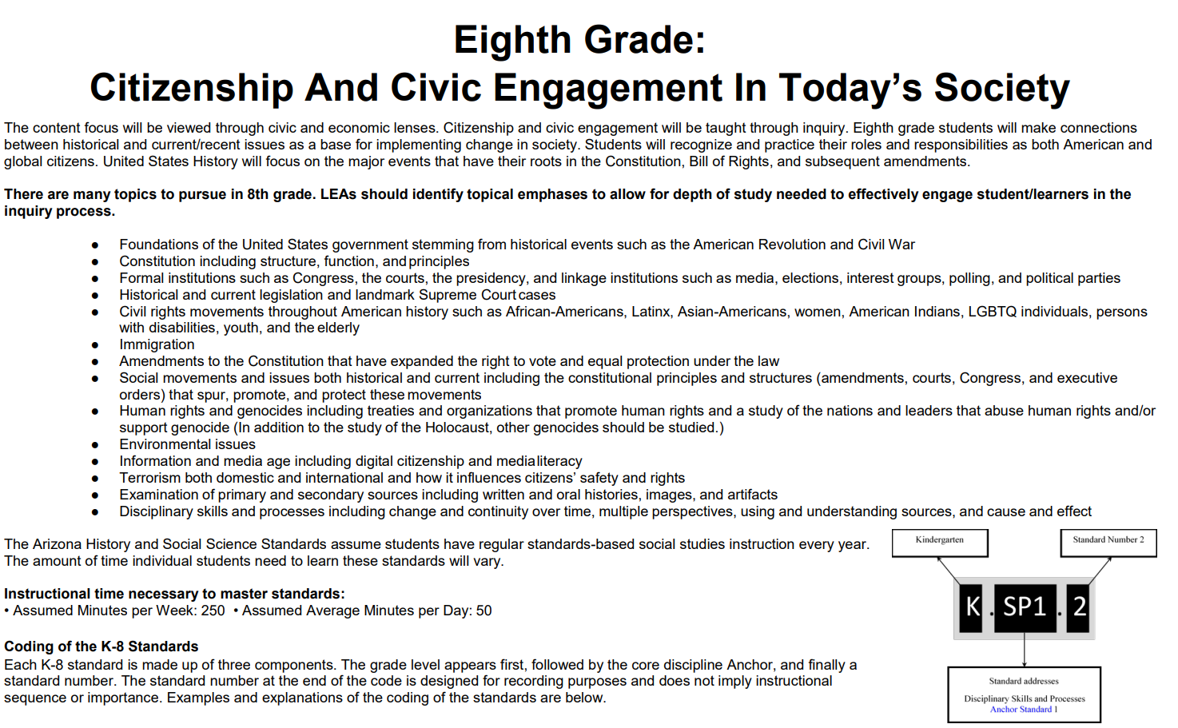

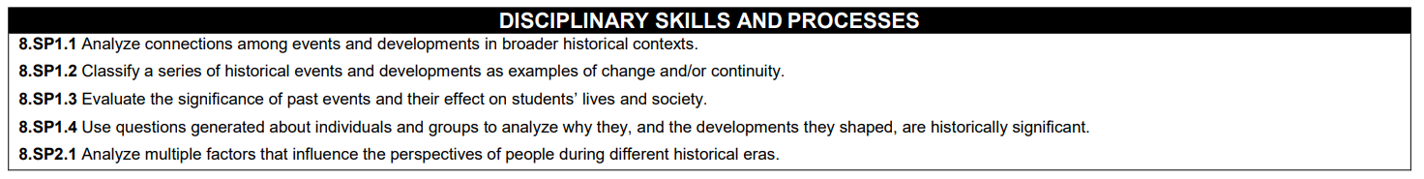

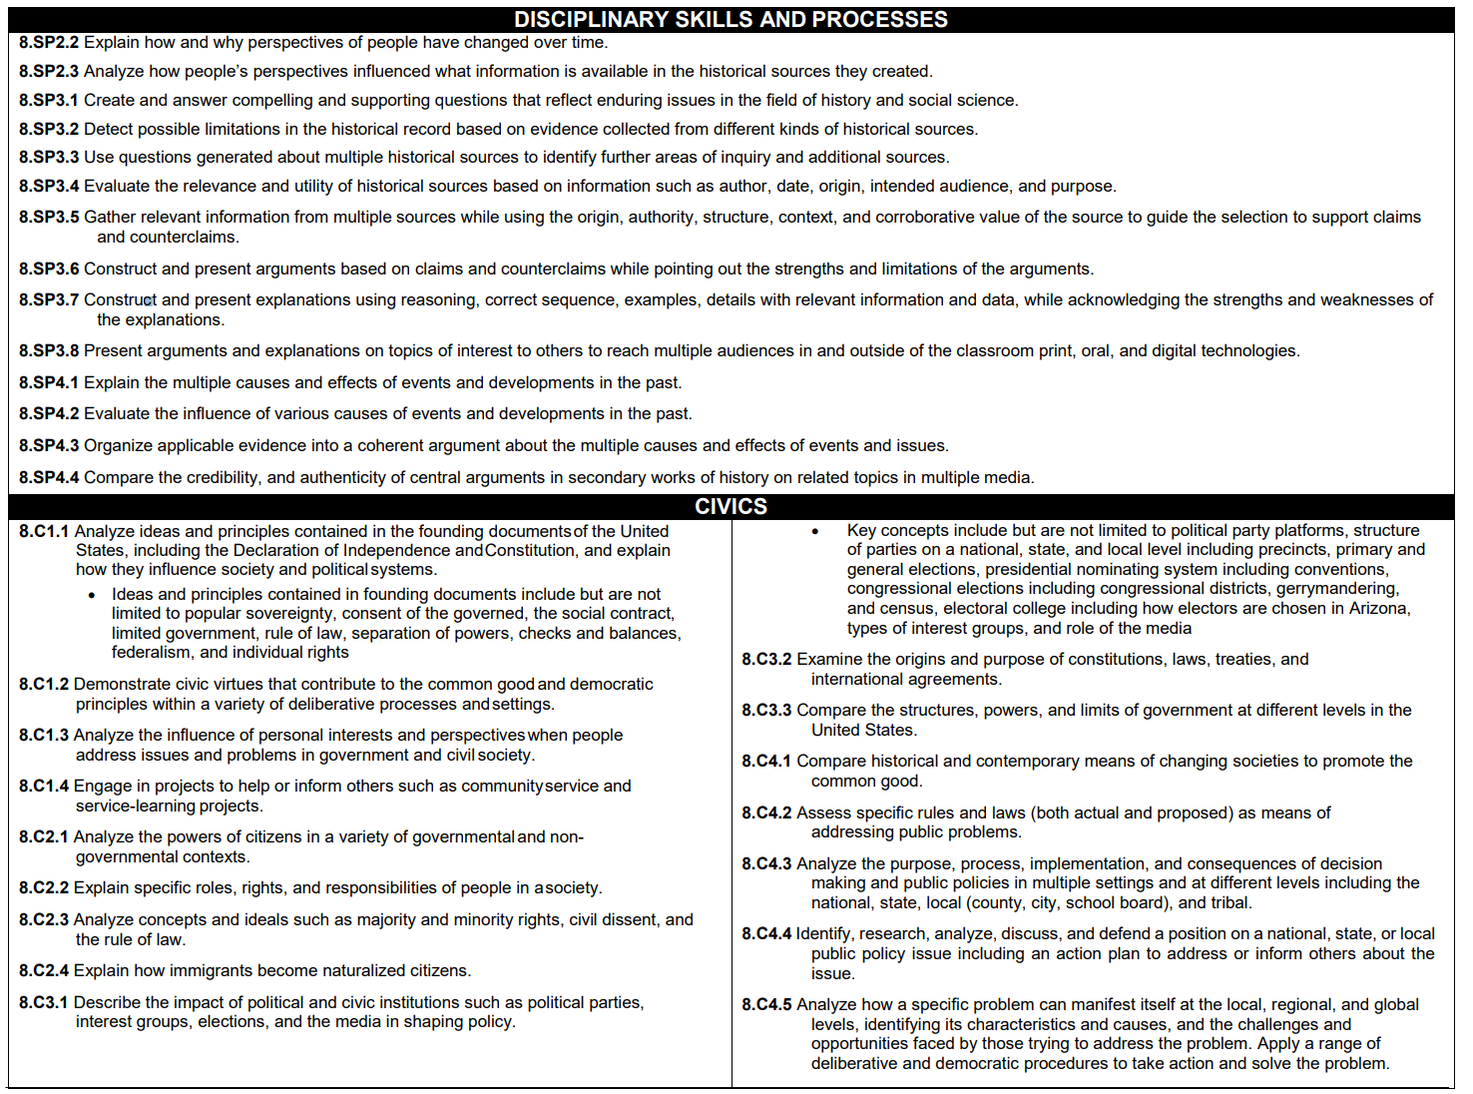

Content Focus:
The content focus will be viewed through civic and economic lenses. Citizenship and civic engagement will be taught through inquiry. Eighth grade students will make connections between historical and current/contemporary issues as a base for implementing change in society. Students will recognize and practice their roles and responsibilities as both American and global citizens. United States History will focus on the major events that have their roots in the Constitution, Bill of Rights, and subsequent amendments.

Topics:
There are many topics to pursue in 8th grade. LEAs should identify topical emphases to allow for depth of study needed to effectively engage student/learners in the inquiry process.

- Foundations of the United States government stemming from historical events such as the American Revolution and Civil War
- Constitution including structure, function, and principles
- Formal institutions such as Congress, the courts, the presidency, and linkage institutions such as media, elections, interest groups, polling, and political parties
- Historical and current legislation and landmark Supreme Court cases
- Civil rights movements throughout American history
- Immigration
- Amendments to the Constitution that have expanded the right to vote and equal protection under the law
- Social movements and issues both historical and current including the constitutional principles and structures (amendments, courts, Congress, and executive orders) that spur, promote, and protect these movements
- Human rights and genocides including treaties and organizations that promote human rights and a study of the nations and leaders that abuse human rights and/or support genocide (In addition to the study of the Holocaust, other genocides should be studied)
- Environmental issues
- Information and media age including digital citizenship and media literacy
- Terrorism both domestic and international and how it influences citizens’ safety and rights
- Examination of primary and secondary sources including written and oral histories, images, and artifacts
- Disciplinary skills and processes including change and continuity over time, multiple perspectives, using and understanding sources, and cause and effect

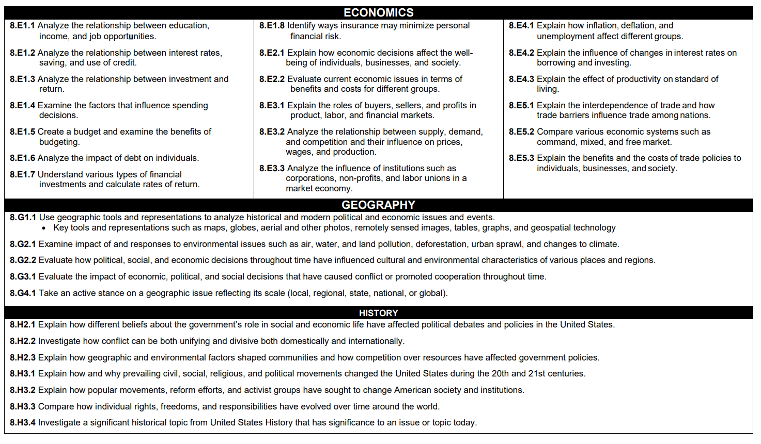

Course Overview: U.S. History is the primary emphasis for eighth grade. Eighth grade utilizes a thematic approach to the teaching of social studies. The eighth-grade social studies themes include, “What Does It Mean to Be an American,” “Westward Expansion,” “Americans and Equality,” and “Why [Civil] War?” Political science and citizenship, economics and the behavioral sciences are taught within the context of U.S. History, which includes the Constitution to the present with an emphasis on the years 1787-1877. Geography is taught within the context of the history of the United States. Current events are also a part of the eighth-grade social studies curriculum.

Curriculum Pacing:

Topics/Units: | Time Frame:
1. What Does it Mean to be an American? Part A: Students will study the historical events that led to the Revolutionary War. | 6 weeks
2. What Does it Mean to be an American? Part B: Students will study and examine the documents that form the framework of the U.S. government. | 6 weeks
3. How did US expansion and growth transform the nation? Part A: Students will examine how the U.S. acquired large tracts of western lands and reasons behind migrations west. | 5 weeks
4. How did US expansion and growth transform the nation? Part B: Students will examine the industrial, immigration, and labor growth of the U.S. during the 18th and 19th centuries. | 5 weeks
5. How do Americans Strive for Equality? Part A- Native Americans: Students will explore the history of Native American inequality within the U.S. | 2 weeks
6. How do Americans Strive for Equality? Part B-Women: Students will examine the struggle for women’s equality and their changing roles in society. | 2 weeks
7. How do Americans Strive for Equality? Part C-African Americans: Students will study and examine the history of slavery and the struggle for African American civil rights. | 3 weeks
8. Why did America go to war against itself?: Students will study and examine the causes, events, and impacts of the American Civil War. | 5 weeks

